Introduction | In these activities, students will explore the data that they gathered with Splash! and apply it to various mathematical tasks.
Time | 1 -2 class periods
Grade | 4-5
Lesson  Preparation | Students will have visited the Tsongas Industrial History Center to participate in the Power to Production program. Students gathered data from the waterwheel test on the Splash! app.  Each student will need a copy of Waterwheels image and a copy of Splash! in Angles worksheet. For each group, you will need a large sheet of paper to be used for idea sharing and to be displayed for the gallery walk.
Vocabulary | Acute Angle  Obtuse Angle  Right Angle
Anticipated Student Preconceptions/ Misconceptions | Students will know how to measure angles, but may need to review measuring with a protractor. Students may think that there is no way an angle can be measured if one side is on a curved surface.
Frameworks | Massachusetts Math Standards  4MD. Geometric measurement: Understand concepts of angle and measure angles.  5. Recognize angles as geometric shapes that are formed wherever two rays share a common endpoint, and understand concepts of angle measurement:  a. An angle is measured with reference to a circle with its center at the common endpoint of the rays, by considering the fraction of the circular arc between the points where the two rays intersect the circle. An angle that turns through 1/360 of a circle is called a “one-degree angle,” and can be used to measure angles.  b. An angle that turns through n one-degree angles is said to have an angle measure of n degrees.  6. Measure angles in whole-number degrees using a protractor. Sketch angles of specified measure.  7. Recognize angle measure as additive. When an angle is decomposed into non-overlapping parts, the angle measure of the whole is the sum of the angle measures of the parts. Solve addition and subtraction problems to find unknown angles on a diagram in real-world and mathematical problems, e.g., by using an equation with a symbol for the unknown angle measure.

Guiding Question | How do the angles of a waterwheel’s blades make the wheel more or less efficient?
Objectives | Students will be able to:  - Measure angles on a curved surface when a tangent line is drawn.  - Describe how using different angle measures in a waterwheel design might contribute to efficiency of a waterwheel.
Activity | - Organize students into groups of three to four students.  - Hand out waterwheel image.  - Students will measure angles A and B (red bucket wheel) and C and D (blue paddle wheel) using a protractor. Students will classify the angles as acute, obtuse, or right by their measures.  - Show students the Splash! data and the wheel/base combination they selected as most efficient. Ask the students what they notice about the relationship between the angles on the red wheel (bucket) and the choices they made.  - Ask students to sketch other blade angles on the worksheet, using their protractor and different colored pencils. They should draw at least 6 blades on each wheel.  - Ask the students to discuss in their small groups what angle measures they think would work best for an efficient waterwheel. Students should create a poster to show their ideas and use their work from worksheet 1 to justify their responses.
Assessment | Gallery Walk – Students display their posters and their choice, and the rational, as to which angle would be the most efficient. Then walk around the room. After the gallery walk, each group will have one “I agree with… because…” statement and one “I disagree with… because…” statement.
Differentiated Suggestions | Students can work in teams to measure angles.  Students can be provided with sentence starters or graphic organizers to put their ideas on paper before sharing out to a whole group.  Students can be organized into the groups they were in for the field trip and have sharing conversations in their small group (see assessment options).
Adapting the Activity for Other Grades | This could be an interesting high school geometry activity involving construction of angles and equal placement of the blades around the outer edge of the small circle. Students could also be asked to recreate a waterwheel given a drawing of one portion of it.

Splash! into Angles Worksheet
Draw a wheel with at least 6 blades that are….

Acute  Angles | 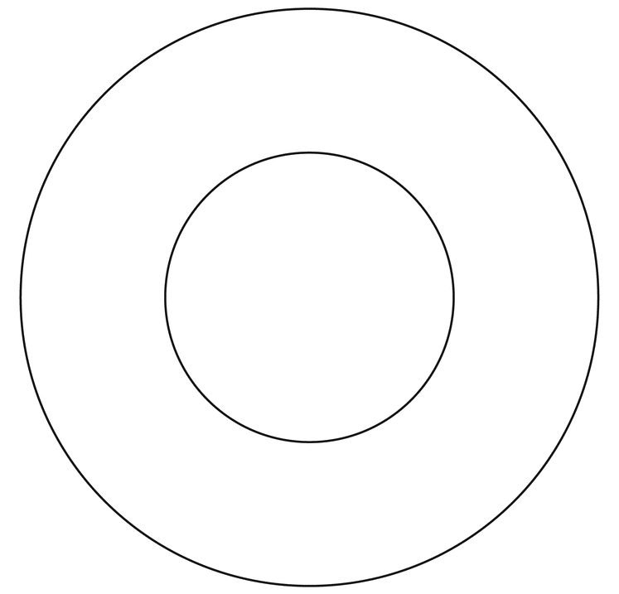
Right
Angles
Obtuse
Angles

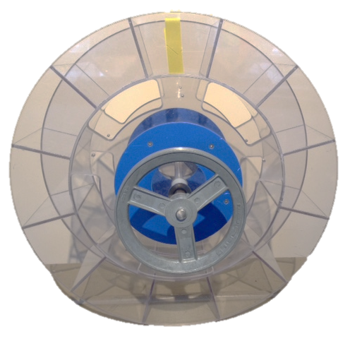
Waterwheels
B
A

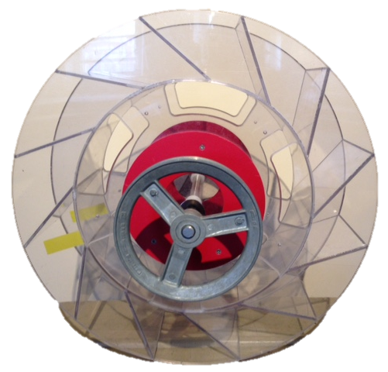
Bucket Wheel
Paddle Wheel

C D

